Declaring Tolerances in Autodesk Inventor
Figure 1 shows three parts, an arm, a pin, and a grip that are to be assembled together. The pin is force fit (FN2) into the arm, while the grip is free to turn about the pin (RC2).
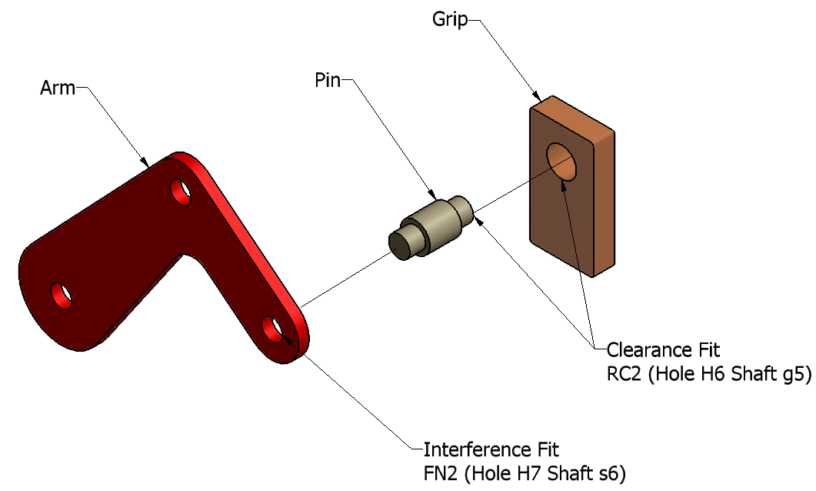
Figure 1

Figure 2 shows drawing views of the three parts, along with dimensions and tolerance limits for the critical features.
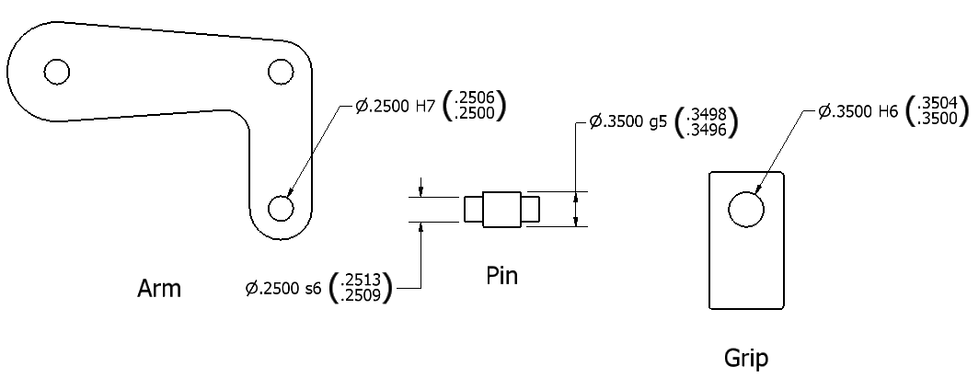
Figure 2

In order to create the toleranced dimensions shown in Figure 2, several options were used in the AI drawing environment.

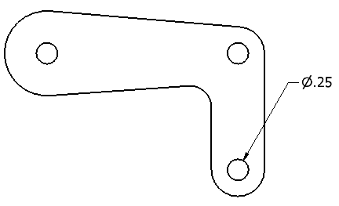
Figure 3

Figure 3, for example, shows the arm part after the hole has been dimensioned. To increase the precision of the dimension to four decimal places, right-click on the dimension, then select Precision > 4, as shown in Figure 4.

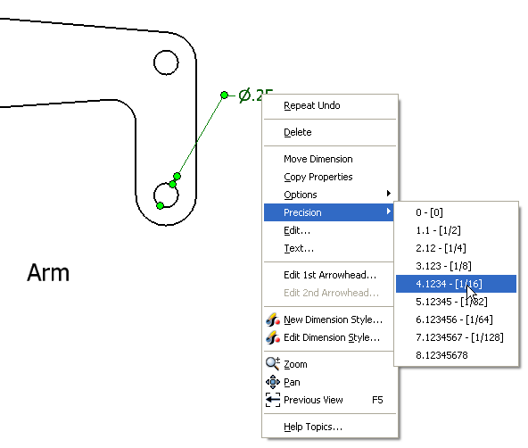
Figure 4

To specify the tolerance, once again right-click on the dimension, and select Edit…, as shown in Figure 5.
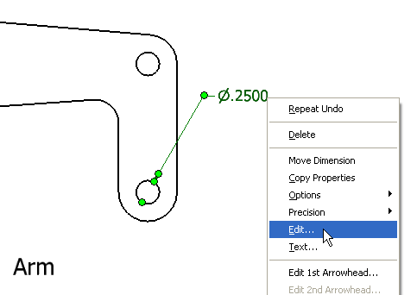
Figure 5

The Edit Dimension dialog box, shown in Figure 6, appears. In the Precision area of the dialog box (on the right), the precision of both the primary unit (i.e., the basic size), and the tolerance can be set.
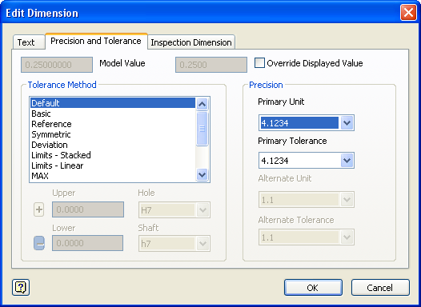
Figure 6

On the left, in the Tolerance Method area, try selecting each of the tolerance methods in turn, and notice how each method impacts the appearance of the dimension.

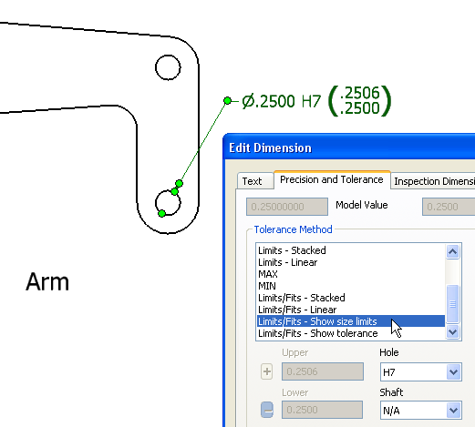
Figure 7

Figure 7 shows the tolerance method used to display the tolerances as they appear in Figure 2 – Limits/Fits – Show size limits. The Hole drop down box is set to H7. The Shaft drop down box is automatically set to N/A, since hole tolerances are being specified.
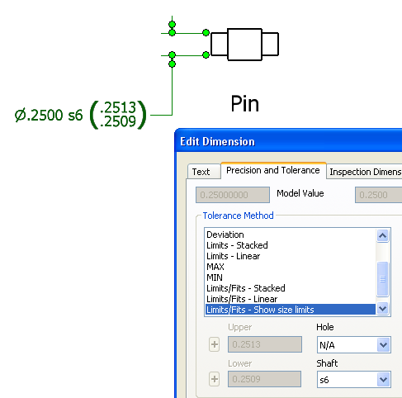
Figure 8

In Figure 8, the settings used to obtain the shaft tolerances on the pin are shown. The Hole drop down box is set to N/A, and the Shaft drop down box is s6. An FN2 interference fit is designated H7/s6.

